Blended Lesson (Introduction to Programming)

Question 1.
- Design the program
- To prevent any potential errors that can be occurs in the future where a rework is needed.
- Write the code
- To convert the idea from the design into an actual code where computer can understand and execute it.
- Correct syntax error
- To make sure there are no mistakes that disobey the rules of the programming language.
- Test the program
- To make sure that there are no errors while using the program and improve the quality of the program.
- Correct logic errors
- To ensure that the program runs as what we expected based on the designing of the program.
Question 2.
- START
Input the first number
Input the second number
Calculate the sum of the first and second numbers
Display the sum
END

- START
Input the age
If age < 18 and age > 13 then
Display “You are a teenager.”
Else
Display “You are an adult.”
END
Question 3.
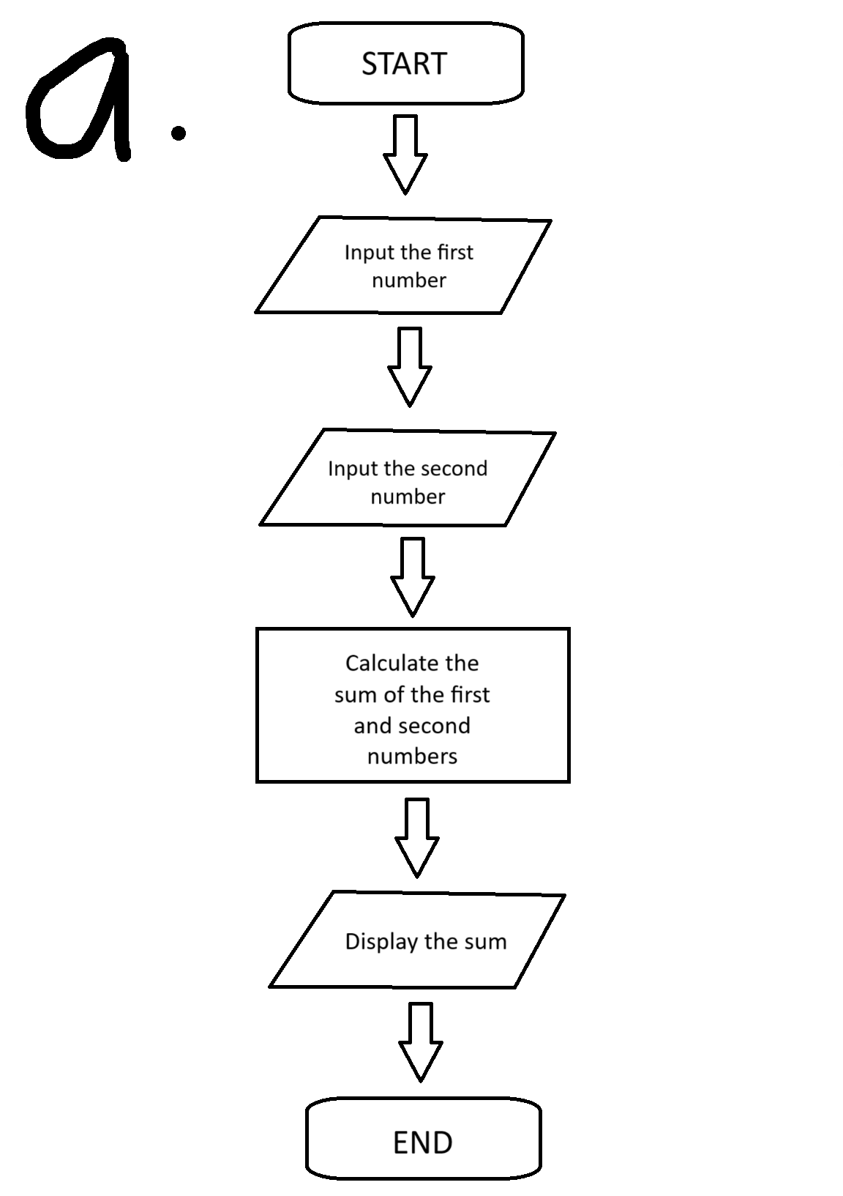
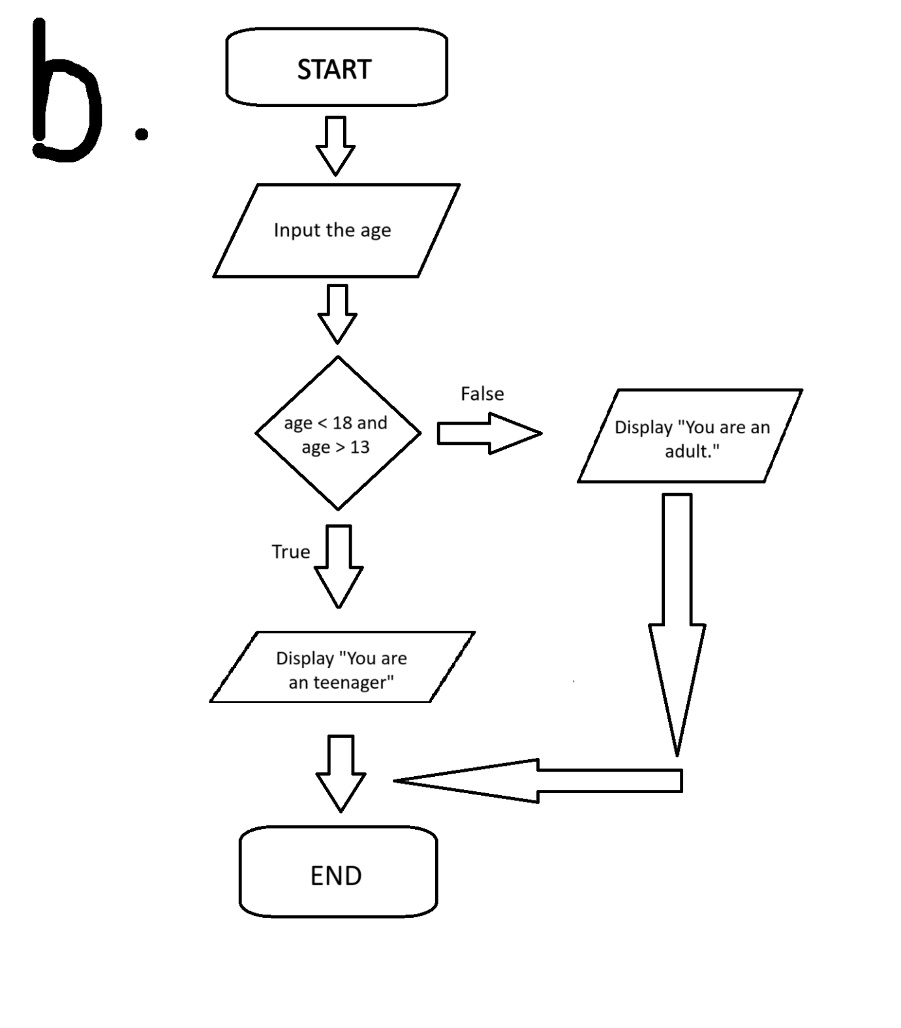
Question 4.
- Input: Inputs the value of Celsius
Process: Converts the value of Celsius to Fahrenheit
Output: Display the converted value from the process

- Input: Inputs the value of the length and width of a rectangle
Process: Multiply the value of length and width
Output: Display the calculated value from the process
Question 5.
- START
Set num = 0
Set count = 0
Input num
While count < num do
Set count = count + 2
If count = num then
Display “The inputted number is even.”
Else
Display “The inputted number is odd.”
END

- START
Set num = 1
While num < 11 do
Display num
Set num = num + 1
END

